**Geographical Presence:**

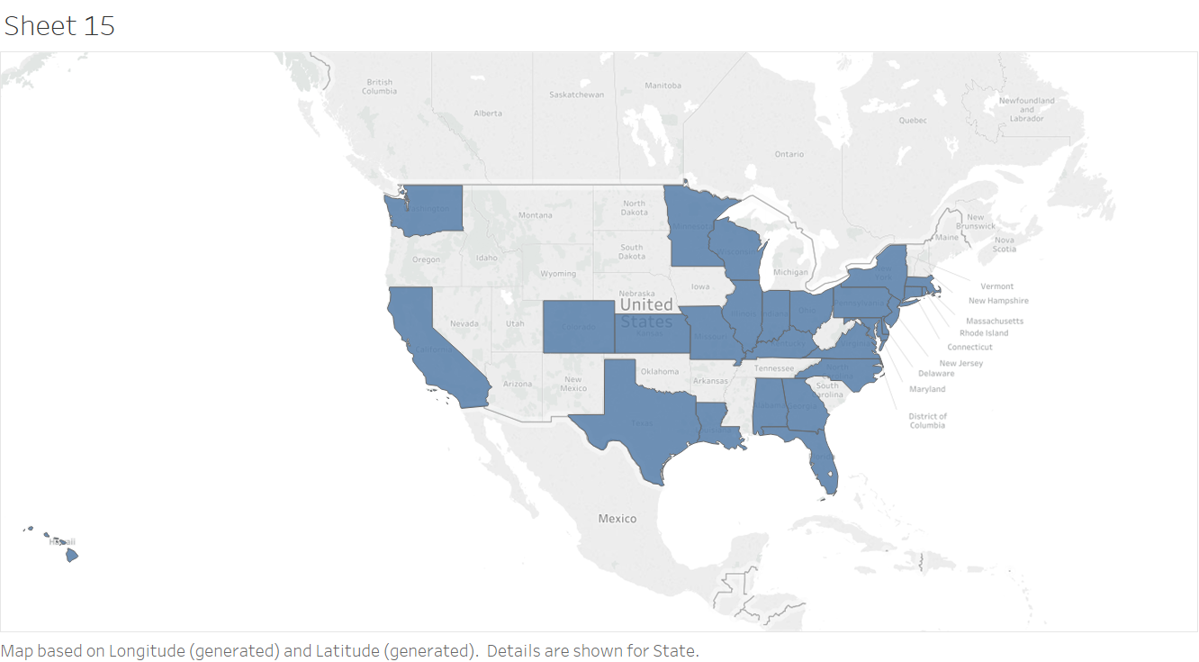

Figure 1: Geographical presence of the plumbing company

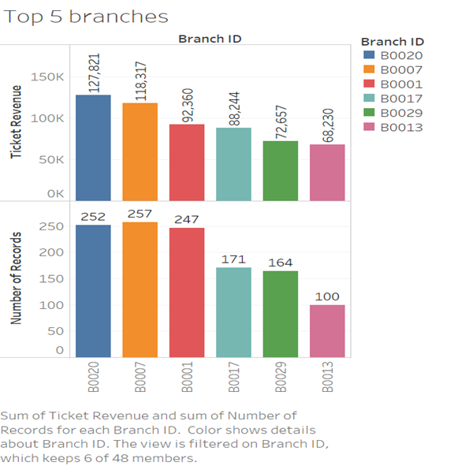

Figure 2: Top 5 branches for revenue and number of service calls

The company operates a total of 47 branches across 28 states of the United States of America. Each branch mostly covers a single state; however, a few branches cover multiple states, and a few states have multiple branches. The geographical presence is shown in Figure 1, and details of the Branch ID, the state in which its operates, the number of ticket counts and the sum of ticket revenue for each of these branches is given in Table 1. Overall the company has received 5069 service calls and has generated a revenue of $2,274, 460 within the three years. There are 4 branches with a cumulative revenue of over $80,000 (Branches 20, 7, 1 and 17) over the three years, and 37 branches with revenue more than $ 50,000 over the same time frame. The top 5 revenue generating branches, and the branches that receive the most number of service calls are shown in Figure 2.

Table 1: Branch ID by State, number of records and total revenue

|  |  |  |  |
| --- | --- | --- | --- |
| Row Labels | Count of State | Sum of Sum of Ticket Revenue | Sum of Count of Ticket Number |
| B0001 | **6** | **92360.03** | **247** |
| 2011 | 2 | 25692.82 | 77 |
| 2012 | 2 | 33458.1 | 90 |
| 2013 | 2 | 33209.11 | 80 |
| B0007 | **9** | **118316.94** | **257** |
| 2011 | 3 | 24507.8 | 65 |
| 2012 | 3 | 38438.68 | 88 |
| 2013 | 3 | 55370.46 | 104 |
| B0017 | **3** | **88243.76** | **171** |
| 2011 | 1 | 15242.35 | 46 |
| 2012 | 1 | 24960.1 | 50 |
| 2013 | 1 | 48041.31 | 75 |
| B0020 | **3** | **127820.77** | **252** |
| 2011 | 1 | 41672.55 | 75 |
| 2012 | 1 | 38749.97 | 87 |
| 2013 | 1 | 47398.25 | 90 |
| B0029 | **3** | **72656.66** | **164** |
| 2011 | 1 | 20475.99 | 37 |
| 2012 | 1 | 24442.17 | 70 |
| 2013 | 1 | 27738.5 | 57 |
| Grand Total | **24** | **499398.16** | **1091** |

**Customer ID:**

There are total 1058 unique customers, the average number of calls per customer is 5, and the average spending per customer over the time frame is $ 2000. The number of calls made by month for 2011, 2012, and 2013 are shown in Figures 3, 4 and 5 respectively. There is no specific trend observed, and this can be attributed to the nature of the business. Approximately 34% of the customers have used the services of the company for in all three years and are considered returning or base customers. They contribute about 30 % of the total revenue generated by the company. On an average about 250 calls are made by new customers every year. Over the same time frame, about 8% (85/1058) of the customers did not choose to use the services of the company after 2012. These are considered as lost customers

Figure 3: Total Calls Month-wise 2011

Figure 4: Total Calls Month-wise 2012

Figure 5: Total Calls Month-wise 2013

**Customer Type:**

There are total of three customer types classified as Type 1, Type 2 and Type 3 respectively. Figure 6 shows business by customer type across the entire country. The major contribution in terms of both the number of calls and the revenue generated is from customer Type 1 followed by Type 3. Approximately 57% of the company’s revenue are from Type 1 customers. The average weekly revenue generated by such customers is approximately $ 1138.

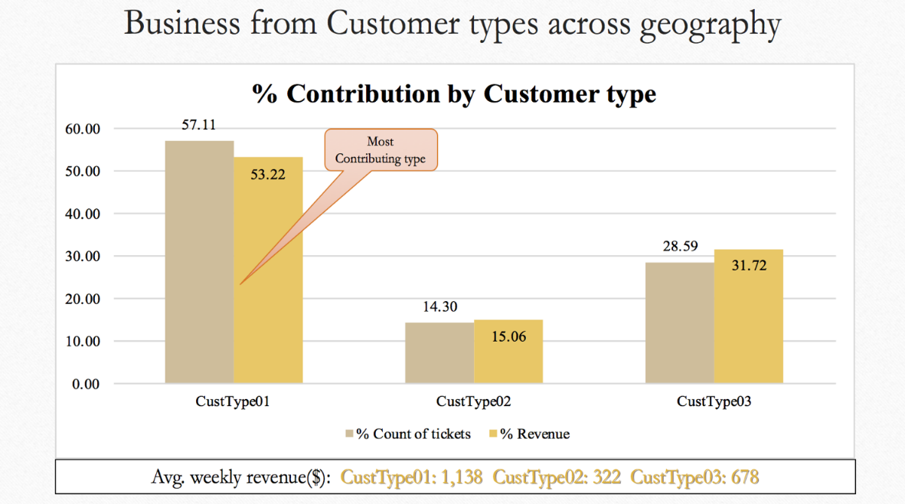

Figure 6: Business from Customer Type across geography

Table 2: Revenue from base customers classified by type

|  |  |  |  |  |
| --- | --- | --- | --- | --- |
| Customer Type | % of Base Customers | Avg. Spend | % Of Calls made | No. of Customers |
| Type 1 | 36.81 | 418.50 | **56.79** | **600** |
| Type 2 | 39.78 | 473.07 | 14.21 | 151 |
| Type 3 | 24.67 | 500.50 | 28.99 | 307 |

Table 2 shows data for base customers classified by type. Again around 57 % of the calls were made by Type 1 customers who make up approximately 37% of the base customers, and spend on an average $ 419. Type 2 customers represent about 40% of base customers and spend on an average $ 473. Type 3 customers make up 25% of the base customers, make around 29% of service calls and spend an average of $ 500. It can be derived that Type 3 customers require specialized tasks that generate higher revenues for the company. More insights can be obtained by analyzing the Job Codes against Customer Type.

**Job Code:**

Analysis by job code shows that there are 34 unique job codes used across various branches. Table 3 lists data of job codes that are not only used most often, but also generate revenue of greater than $ 50,000 for the period under consideration.

Table 3: Revenue and ticket counts of Job Codes with revenue greater than $ 50,000

|  |  |  |
| --- | --- | --- |
| Job Code | Count of Ticket Number | Sum of Ticket Revenue |
| 2 | 631 | 370439.56 |
| 1 | 872 | 322487.37 |
| 0 | 391 | 260756.11 |
| 5 | 622 | 152724.67 |
| 9 | 244 | 141072.03 |
| 13 | 164 | 125651.17 |
| 4 | 300 | 99793.90 |
| 25 | 310 | 99225.37 |
| 29 | 271 | 81517.30 |
| 18 | 45 | 70330.66 |
| 30 | 118 | 60261.26 |
| 8 | 58 | 59455.28 |
| 14 | 90 | 54216.57 |
| 23 | 114 | 54187.72 |
| Grand Total | 4230 | 1952118.97 |

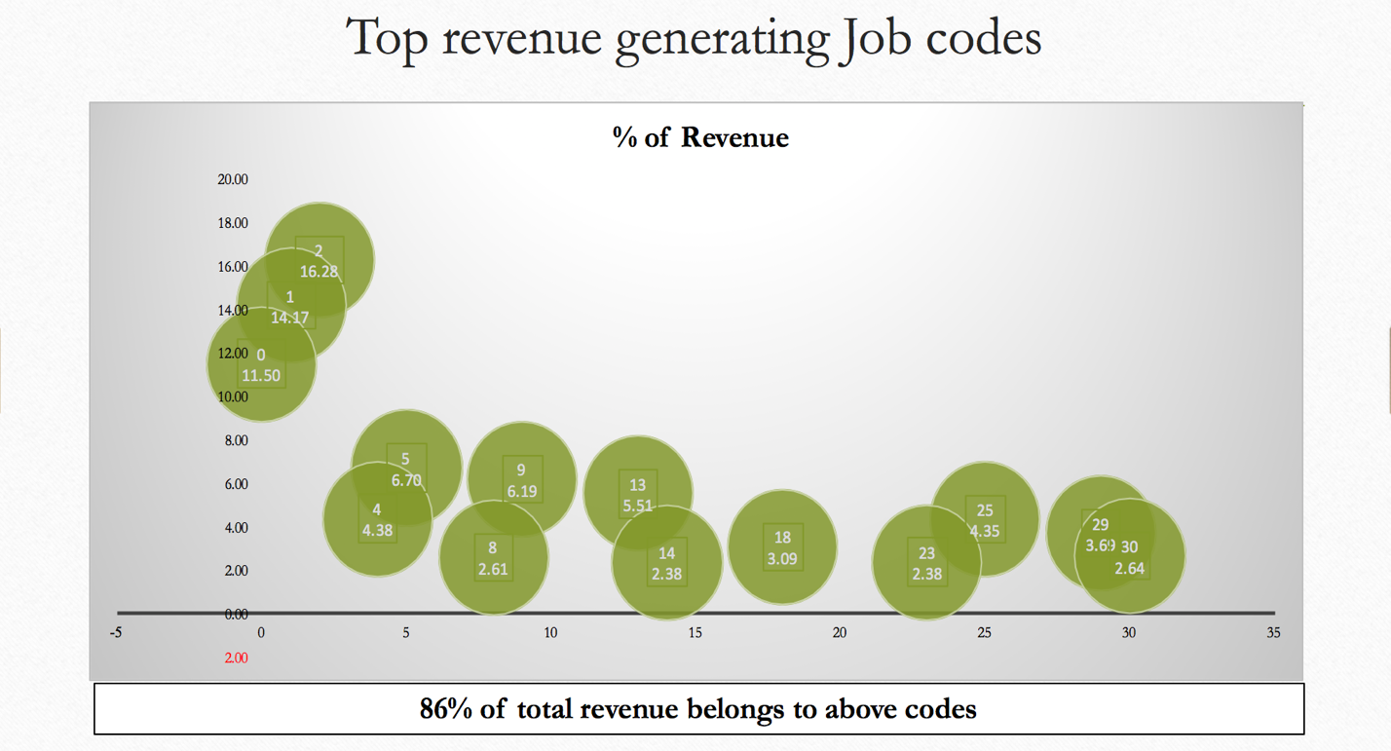

Figure: 7 Top Revenue Generating Job codes

Figure 7 shows data of the top revenue generating jobs codes. The data represented contributes to about 86% of the total revenue generated by the company of which Job codes 2, 1 and 0 respectively contribute about 43 %.

**Ticket Revenue:**

This column helps understand revenue generated from each individual ticket in conjunction with branch, customer type and job code.

C**all date, schedule date, dispatch date and complete date:**

These columns help prepare analysis of trend, seasonality, yearly, monthly and day of week, etc. for each branch, Customer type and job code

**Call time, schedule time, dispatch time and complete time:**

These columns help understand and derive Time of Day analysis, avg. service time for jobs across branches, also disgruntled customers

**State/City:**

Gives geographical information of customer and will contribute in branch/state level analysis

Churn:

Customer who did not show in last 6months are flagged as lost/churned customers. Based on this we defined Churn variable for our training and test data.

**Trend and seasonality Study Jan 2011 till Dec 2013 for service calls:**

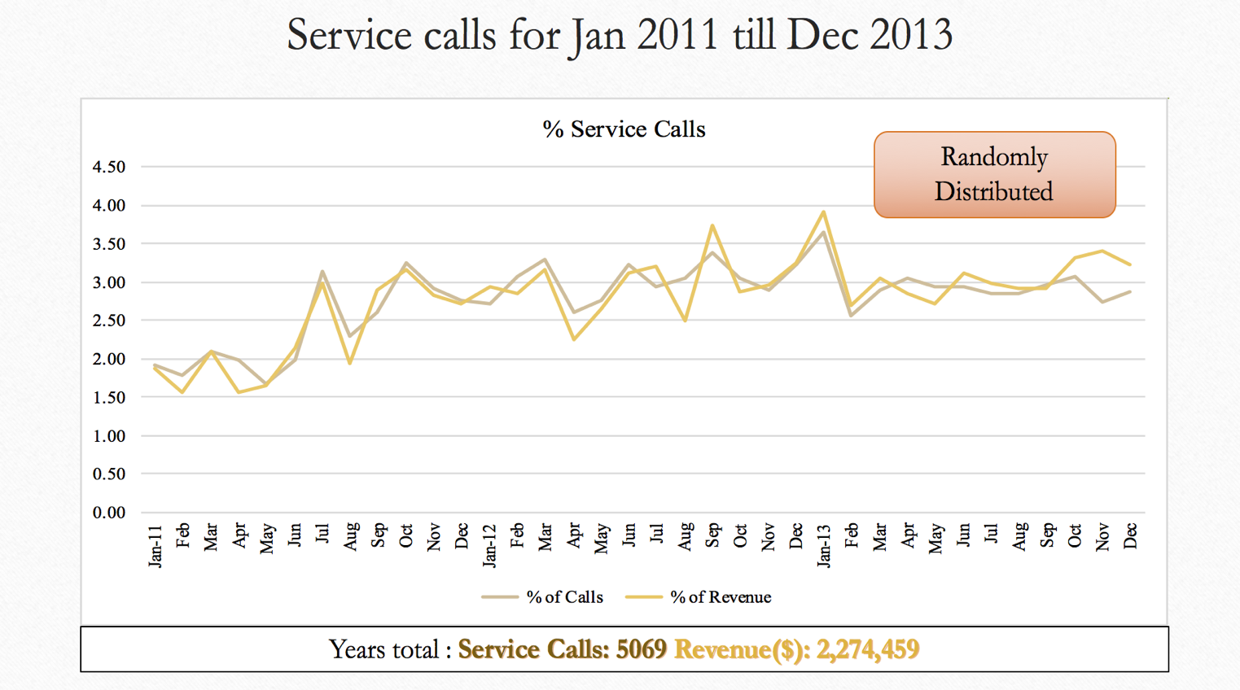

Figure 8: Service calls from Jan 2011 to Dec 2013 on scale of % #of Calls and % of Revenue

Figure 8 shows trend of service calls over between Jan 2011 to December 2013. A total of 5069 service calls were made that generated a revenue of $ 2274459 for the company. Overall, both curves are randomly distributed with no discernable trend visible. This can be attributed to the random nature of the plumbing business as customers call only when there is a requirement. There is generally no fixed planned or routine maintenance activities for these services. Service providers can come up with innovative ideas that attract customers for routine service and maintenance activities in this area.

**Day of week analysis:**

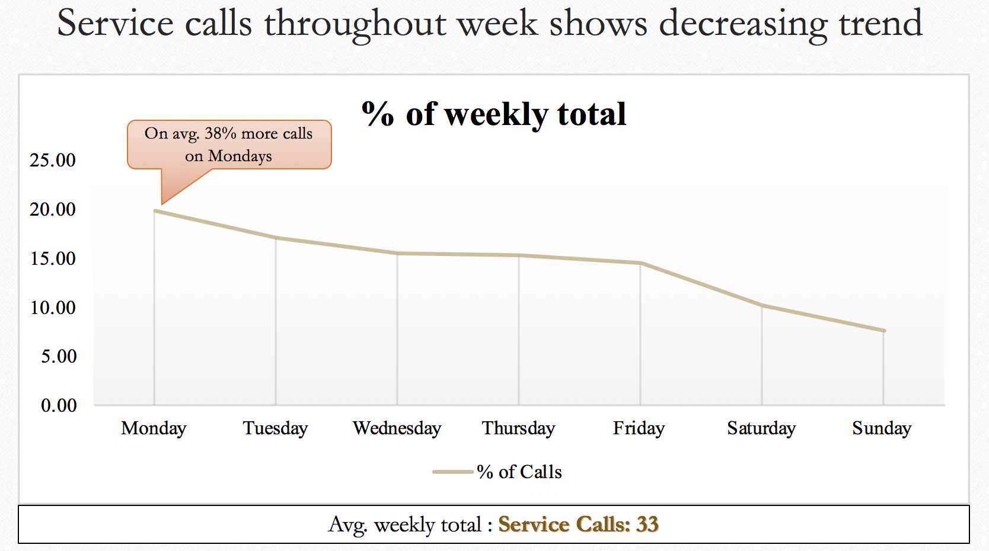

Figure 9: Service call throughout week

A typical week of the business is shown in Figure 9, with Mondays receiving on an average 38% more calls compared to the rest of the week. On an average around 33 service calls are received per week across all branches. In general, the number of service calls falls from Monday to Wednesday. This can be attributed to the general home owner/customer tendency of putting away routine maintenance tasks for the weekend as they get busy with the work week. Thursdays and Fridays see a slight increase in the number of calls. Saturday and Sunday see the lowest number of calls, and these could mainly be attributed to emergency calls.

**Hour of Day Analysis:**

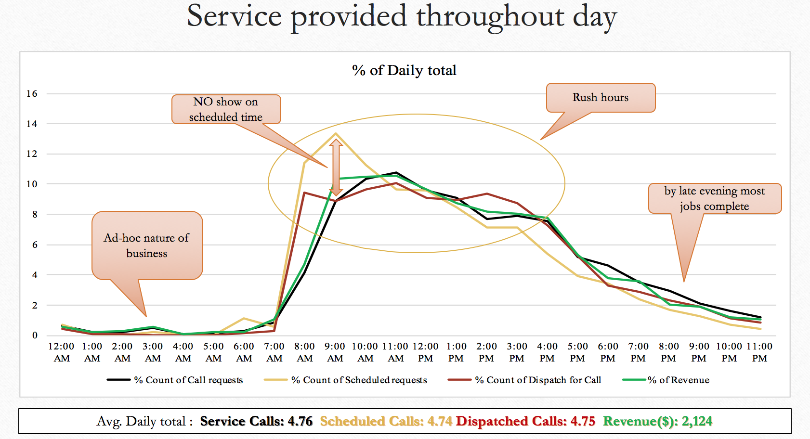

Figure 10: Service call throughout Day

A typical work day is shown in Figure 10. On an average about 4.7 calls are received per day and average revenue earned per day is $ 2124. Generally, due to the ad-hoc nature of the business, service calls are received throughout the day. A very small amount of service calls with corresponding to lower revenues are seen during the early morning hours between 12:00 AM to 7:00 AM. The activities start to increase from 7:00 AM with a peak at 11:00 AM and then begin to decrease towards the end of the day. The peak hours for calls received, plumbers dispatched on service calls, and revenue generated is between 7:00 AM to about 4:00 PM. The service call volume and revenues decrease from 4:00 PM to 11:00 PM.

**Sales drilled down per Transaction level:**

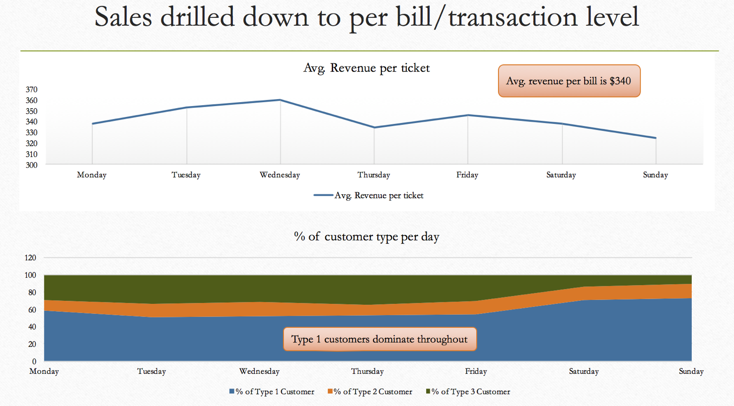

Figure 11: Sales drilled down to transaction level

Data of sales drilled down to transaction level is shown in Figure 11. The average revenue per bill is $ 340. The highest average per transaction is on Wednesday (average $360). The figure also shows that Type 1 customers dominate throughout the week.

**Univariate Analysis of Churn:**

In order to understand the customers that have churned, an univariate analysis of different variables that are expected to influence churn versus customers that have churned is carried out. The first variable studied is churn based on the average number of hours taken to complete the work. The data is shown in Figure 12. The highest number of calls (200) are received for calls that require between 2 and 2.5 hours to be completed of which about 75 calls (30%) of the customers churn. The highest percent churn (100%) however is for jobs that take between 5.5 to 6 hours to complete.

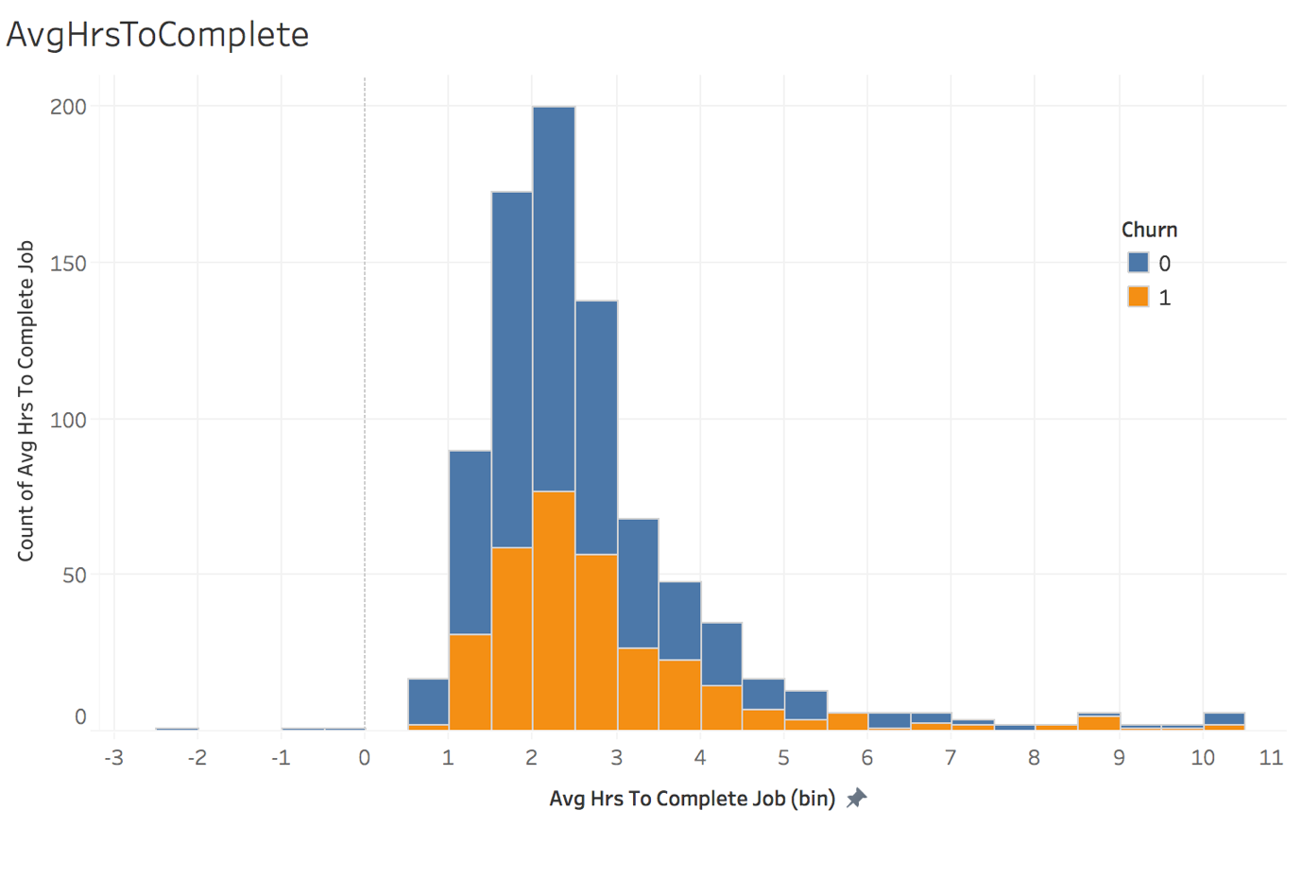

Figure 12: Average time (hours) taken to complete the job

Latency, in this case, is defined as the delay (days) between receiving the service call and completing task. Latency is expected to influence churn, and data of average latency in days versus churn is shown in Figure 13. In general, churn increases with increase in latency. The highest churn occurs for a latency period between 40-60 days.

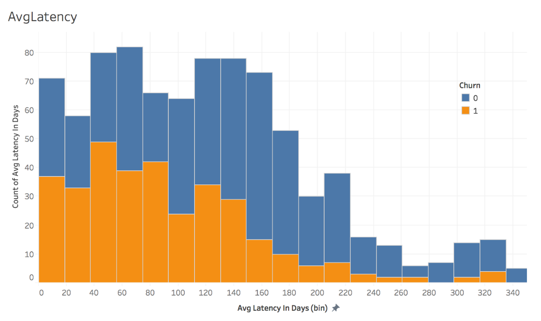

Figure 13: Churn data for latency (days)

Churn data for by count of distinct jobs is given in Figure 14. There are 5 distinct jobs, churn is highest for job count 2.

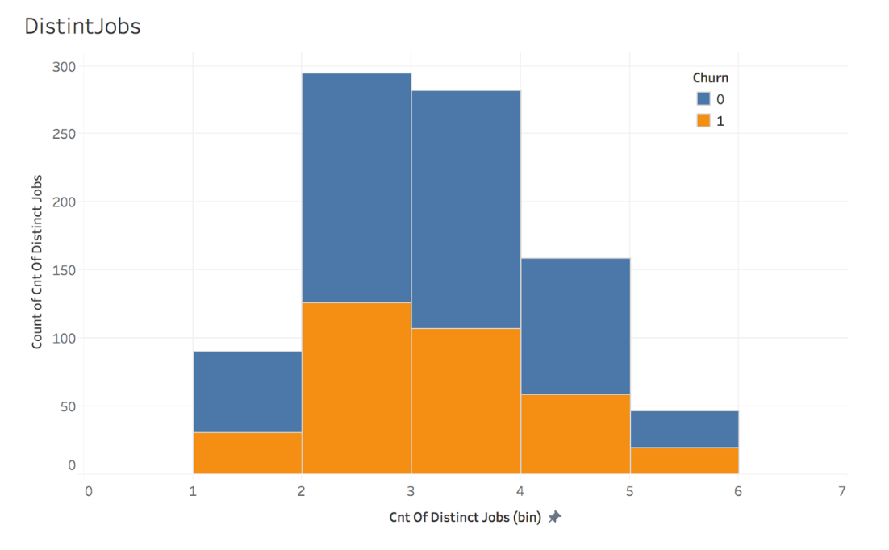

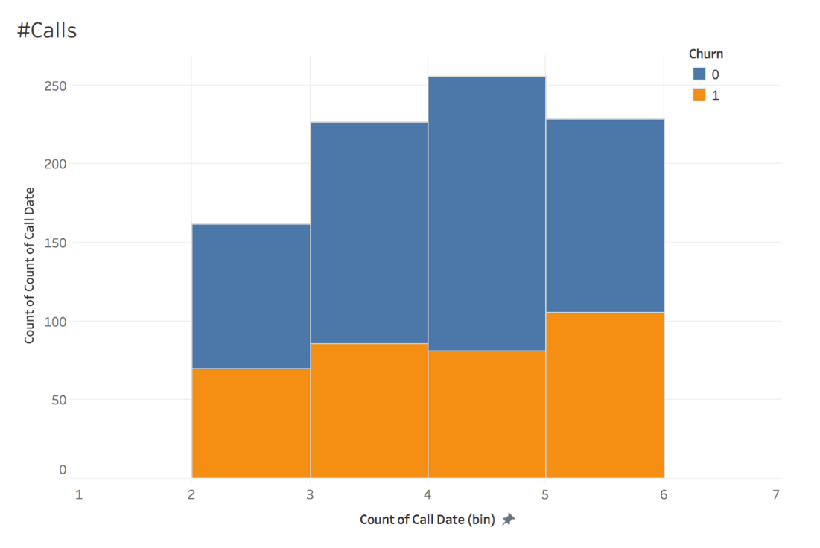Figure 14: Churn by distinct job count

Figure 15: Churn by number of calls on a particular date

Churn by the number of calls on a date is shown in Figure 15. In general churn increases with increase in number of calls. Churn is highest when 5-6 calls are received on a date.

Churn by number of days that have passed since the last service call was made is shown in Figure 16. The figure shows that churn starts when 150 days have elapsed since the last call. The highest churn however occurs between 175 and 200 days since the last call was made.

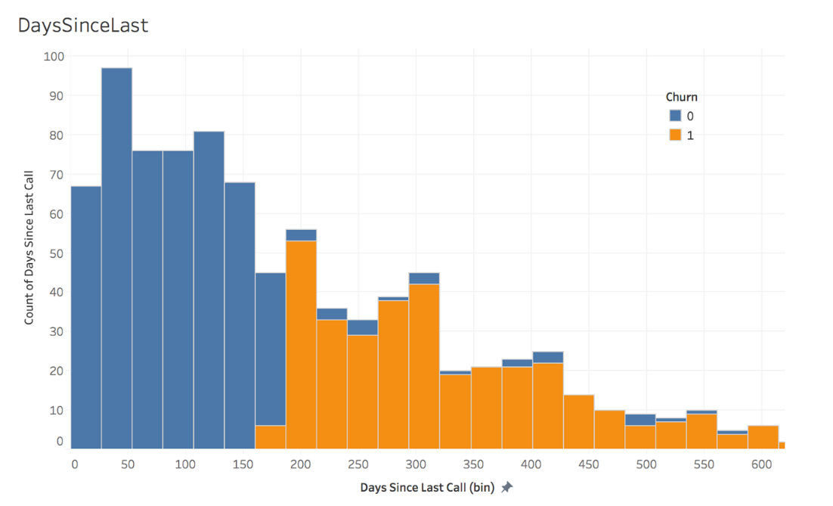

**Figure 16: Churn by number of days elapsed since last call**

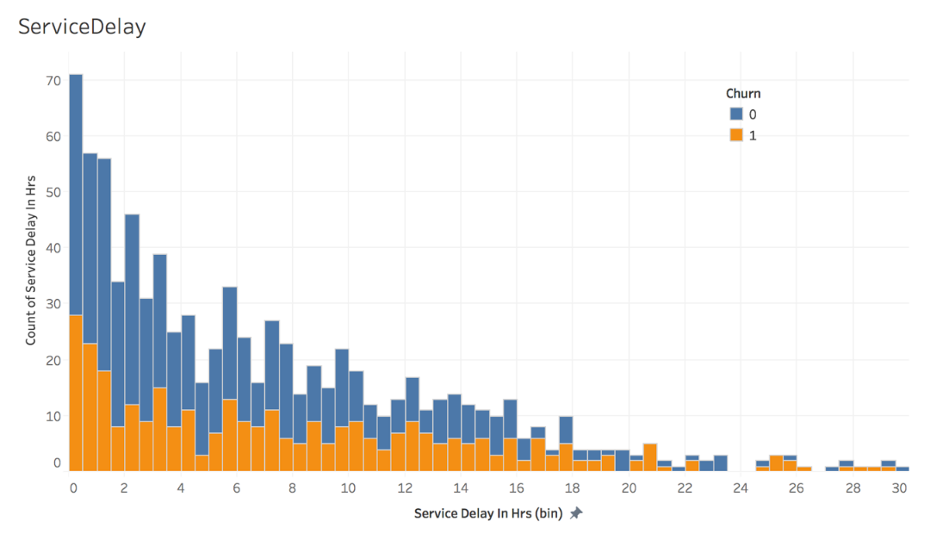

**Figure 17: Churn by service delay**

Churn data as a function of service delay in hours is given in Figure 17. It is generally expected that churn increases with increase in delay. However, contrary to expectations, it is shown that churn is highest for delay between 0 to 1 hours. It is speculated that the churn happens due to the urgent nature of the task. For example, if a customer requires an urgent task to be fixed, and if an associate of the company is not available during that time, then the customer looks for an alternate vendor to attend to the problem.

Churn data by ticket revenue is shown in Figure 18. Highest churn occurs for ticket revenues between $500 to $ 1000.

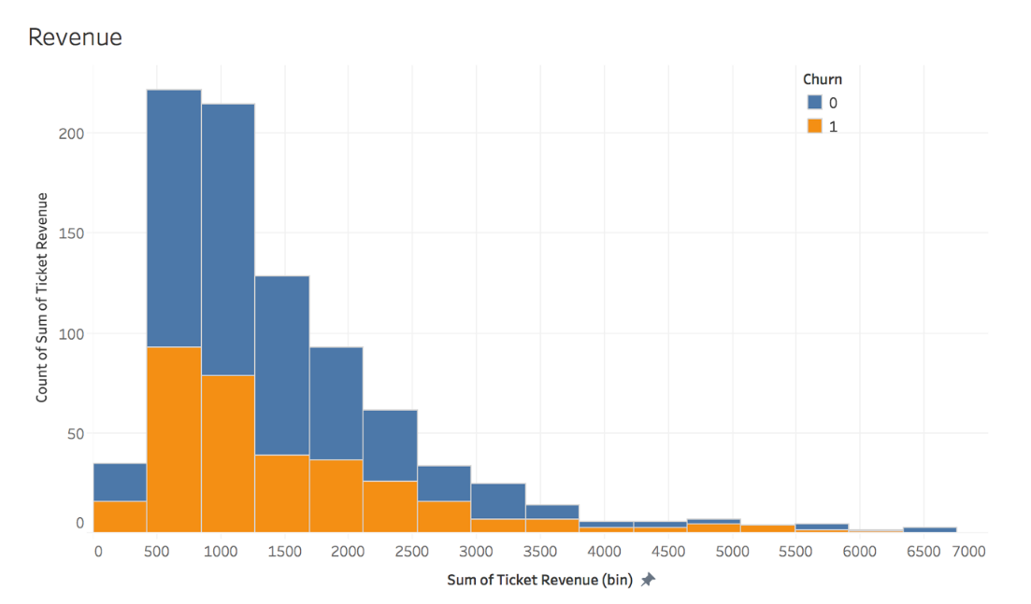

**Figure 18: Churn by ticket revenue**

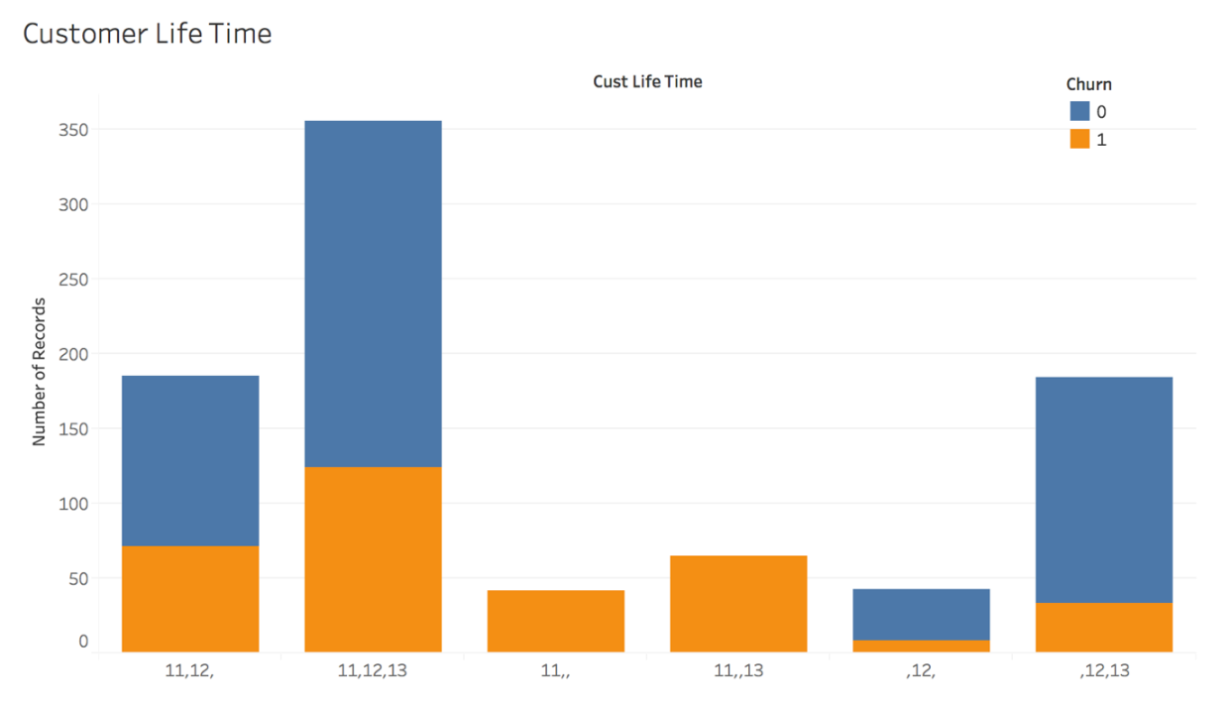

**Figure 19: Churn by customer lifetime**

Churn data by customer lifetime is shown in Figure 19. In general, a lower percentage of churn occurs when customer call for service in consecutive years. Highest percentage (100%) of churn occurs in 2011 customers who do not return for services.

Churn by customer type is shown in Figure 20. As expected the customer type 1 makes the highest number of calls and also has the highest churn among all customer types.

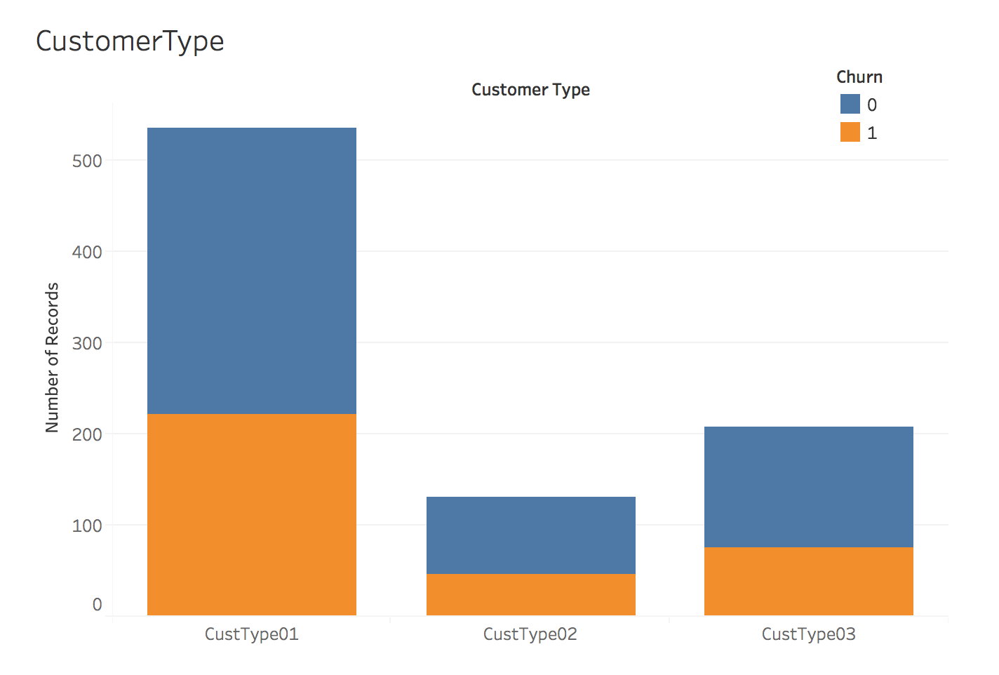**Figure 20: Churn data by customer type**